Toronto Cafe Opening


Introduction/Business Problem

In Toronto a well known worldwide firm of cafes is looking to open a cafe. The kind of investigation they need is to select a neighbourhood that has not many cafes, but instead has a lot of other venues, like museums, universities, restaurants etc.

Toronto is the capital city of the Canadian province of Ontario. With a recorded population of 2,731,571 in 2016, it is the most populous city in Canada and the fourth most populous city in North America.

The demographics of Toronto, Ontario, Canada make Toronto one of the most multicultural and multiracial cities in the world. In 2016, 51.5% of the residents of the city proper belonged to a visible minority group, compared with 49.1% in 2011,[1][2] and 13.6% in 1981.[3] Toronto also has established ethnic neighbourhoods such as the multiple Chinatowns, Corso Italia, Little Italy, Little India, Greektown, Koreatown, Little Jamaica, Little Portugal and Roncesvalles, which celebrate the city's multiculturalism.[4]

The idea is to investigate the neighbourhoods of Toronto and to sort them according to the desired ratio of number of venues/number of cafes.

The neighbourhood with the highest ratio will be the candidate neighbourhood. This is the simpler approach and the model can be further enriched to include if available demographic data and rent costs.

For the venues investigation the Foursquare database is going to be utilized by its respective API.

The queried venues will include every kind of venue and cafes will be treated separately.

Data section

bbb

https://en.wikipedia.org/wiki/List_of_postal_codes_of_Canada:_M

Location-based services like Foursquare are all the rage. If you haven't heard about them yet, you will. It seems that everywhere you turn, people are using Foursquare, Gowalla, Loopt, and other tools to "check in" to their favorite locations, share tips with other users about favorite drinks or dishes, and share all of this activity on other services like Twitter and Facebook.

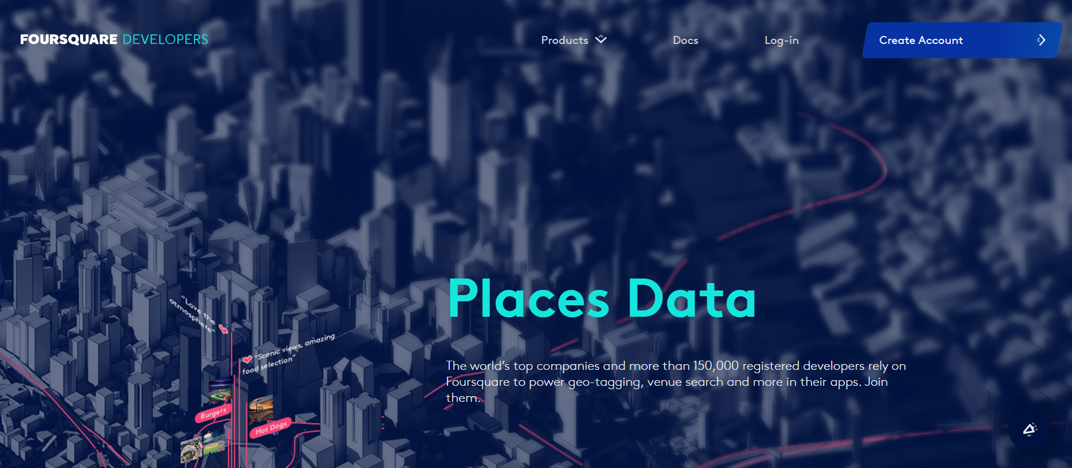

As a developer, you have to know this stuff. Social, and specifically, location-based services that use social platforms, represent a huge growth area for web and mobile developers. Most of these services use some kind of RESTful service you can use to request JavaScript Serialized Object Notation (JSON) or XML data. Some, such as Facebook, don't require much authentication, while others, like Foursquare, have some feeds that do require authentication and some that don't.

For the purposes of this article, I assume that you know something about PHP, but that's about it. I walk through everything else at an easy pace — accessing a Foursquare feed, working through the result set, and cleaning it up. The sample application you build at the end of the article is simple: provide Foursquare with geolat and geolong coordinates and see how many people are currently checked in at nearby locations. Because I live in Austin, Texas, I think it would be interesting to enter coordinates for a spot on Sixth Street and see what's happening in nearby places.

I chose this particular option for two reasons. The first is because it's the simplest feed to access, but unwrapping it gives you a pretty good preview of what you can expect with other feeds. The second is that it doesn't require authentication — after all, you're not looking for details on who is actually checked in, just raw counts. The venues public feed provides a great deal of functionality within the scope of this article.
Foursquare is a social location service that allows users to explore the world around them. Users can download the Foursquare application to their iPhone, Blackberry, or Android phone and sign up for free, then connect their Foursquare accounts to their other social media accounts.

After users download the free application and connect on Facebook or Twitter, they can connect with their friends who are also active on Foursquare. Whenever they or their friends check in to a place (that is, they're at a location and they tell others that they are there), the message is broadcast to their friends via Twitter or Facebook.

When a user checks in enough times, that user becomes the mayor of a location, which may or may not give the user access to special offers, depending on the business running a location. For example, a coffee shop might extend a free drink to anyone who becomes a mayor. Users can also earn badges as they explore and check in to locations, leave tips for other users (for instance, "The margaritas here are great!"), and may even have the opportunity to create locations that haven't appeared yet on the service.

Foursquare launched its API in November 2009, allowing application developers to extend the platform in interesting ways. Developers can build location management tools, custom search engines, and even games and other tools that interact with the Foursquare API. For example, you could build a geolocation game that allows players to also check in to Foursquare locations as a natural byproduct of normal gameplay.

With this view of Foursquare in mind, let's take a look at the Foursquare API.

The Foursquare API allows application developers to interact with the Foursquare platform. The API itself is a RESTful set of addresses to which you can send requests, so there's really nothing to download onto your server. That being said, in this article, you use a set of PHP libraries to help simplify requests and responses, but this is an entirely optional step.

You can currently request output in XML or JSON format, making requests to URLs that look like this: http://api.foursquare.com/v1/user.json. If you don't use an extension on your request, then XML is served back to you. A request to http://api.foursquare.com/v1/user results in an XML output.

There are both GET and POST methods you can use, which means you aren't just limited to reading from feeds, you can also do useful stuff like checking in and creating locations using the API. As for rate limits, your application is limited to 200 requests per hour per method, so you probably want to implement some kind of result caching to "play nice."

For the most part, you want to use basic or OAuth authentication to take full advantage of the various methods and services. The example in this article (/venues) doesn't require any authentication to get started, but it does have additional features available to those who do use authentication.

Methodology
section which represents the main component of the report where you discuss and describe any exploratory data analysis that you did, any inferential statistical testing that you performed, if any, and what machine learnings were used and why.

Results
section where you discuss the results.

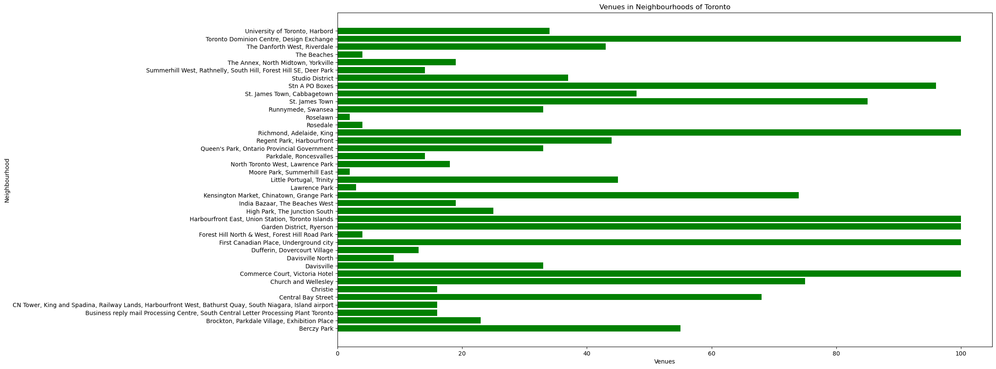

Discussion section where you discuss any observations you noted and any recommendations you can make based on the results.
Conclusion section where you conclude the report.

